GWS REVENUE INFRASTRUCTURE

Interactive Systems Diagram Rationale
Annotated interaction flow and implementation rationale

Executive rationale
The diagram is designed as a compact transformation story: disconnected tools create leakage; Revenue Infrastructure connects those capabilities into one operating system; the connected system produces measurable business outcomes. Interaction is used for progressive disclosure so the visual stays calm at first glance while allowing a visitor to inspect the mechanics without leaving the narrative.
1 DISCONNECTED | 2 CONNECTED SYSTEM | 3 BUSINESS OUTCOMES
Website, search, CRM, response, automation and analytics exist, but operate as separate activities. | Digital Presence, Lead Response, Sales Operations and Revenue Intelligence become coordinated capabilities governed by Diagnose - Design - Implement - Optimize. | The system is judged by Attract, Convert, Retain and Grow - not by tool activity alone.

1. Flow: from fragmentation to infrastructure
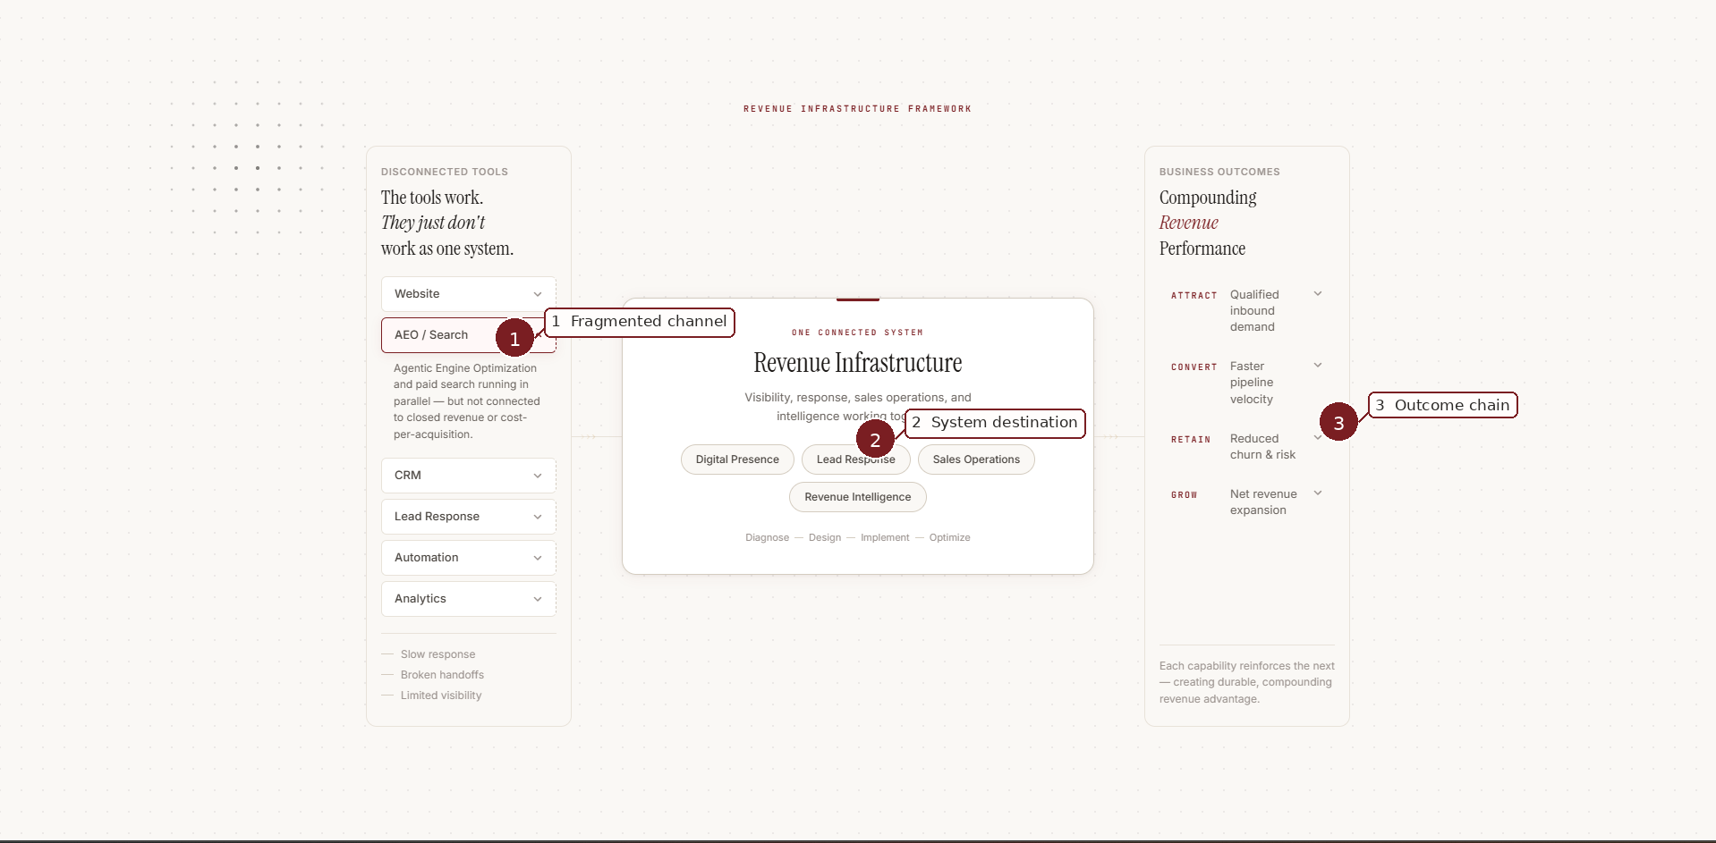
Annotated state: the search/AI layer is opened to expose the gap between channel activity and closed-loop revenue performance.
- 1 - Fragmented channel: the expanded left module explains why a working tool can still underperform when it is not connected to revenue and cost-per-acquisition.
- 2 - System destination: the center reframes the solution as Revenue Infrastructure rather than another tool purchase.
- 3 - Outcome chain: the right column keeps the visitor oriented toward the commercial reason for integration.
Terminology note: this captured state still displays “AEO / Search.” The intended final public-facing label is “Agentic Search.” The expanded copy may retain a precise optimization explanation, but the module label should not introduce a second competing category name.

2. Flow: the center explains what becomes connected
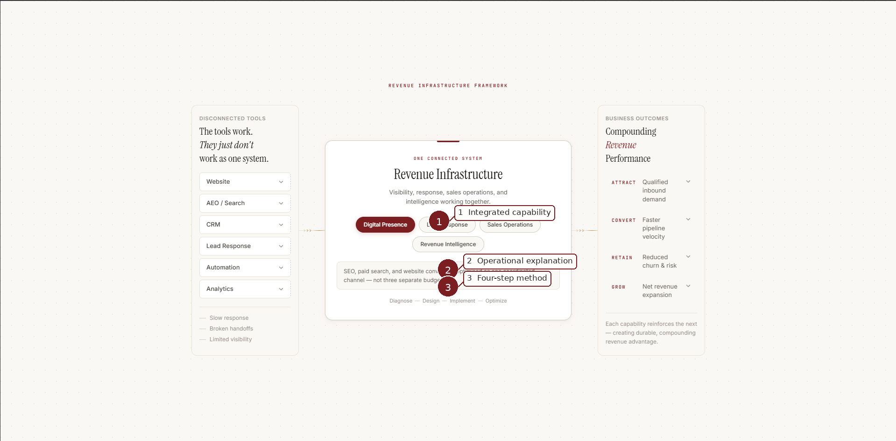
Annotated state: Digital Presence is selected inside the connected-system layer.
- 1 - Integrated capability: the four center modules are the stable solution architecture: Digital Presence, Lead Response, Sales Operations and Revenue Intelligence.
- 2 - Operational explanation: selecting a capability reveals one concise explanation of what integration changes, keeping the diagram educational without turning it into a dense process map.
- 3 - Four-step method: Diagnose - Design - Implement - Optimize remains the standardized methodology summary. It describes how GWS works; it is not a fifth solution module.

3. Flow: the right side translates infrastructure into outcomes
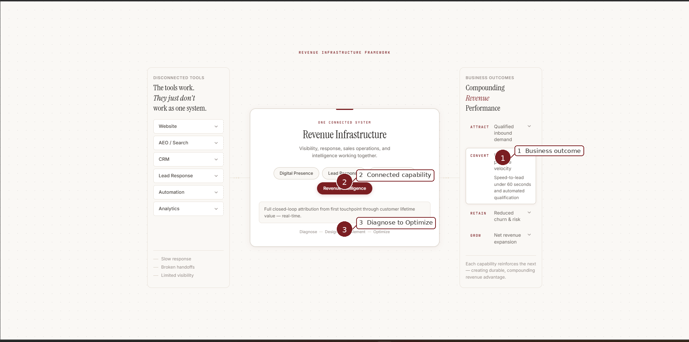
Annotated state: Convert is opened while the connected-system architecture remains visible.
- 1 - Business outcome: Attract, Convert, Retain and Grow are outcome lenses, not service categories. Opening one explains the business effect in concrete terms.
- 2 - Connected capability: the center remains visible so the visitor can mentally connect the outcome to the underlying system rather than treating it as an isolated promise.
- 3 - Method continuity: the methodology stays present as a quiet implementation anchor, preventing the diagram from becoming a feature-to-benefit list with no operating logic.

4. Revenue Intelligence closes the loop
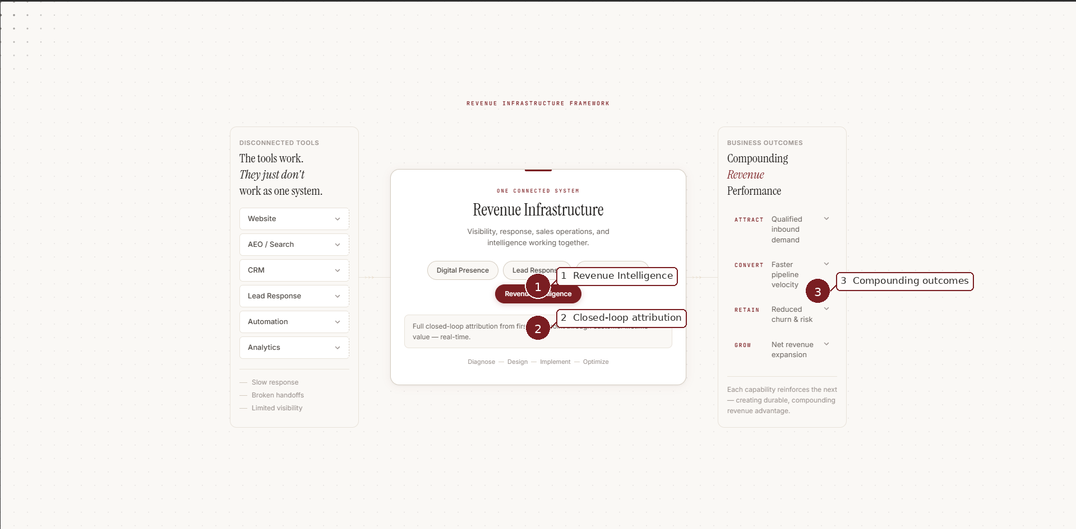
Annotated state: Revenue Intelligence exposes the measurement layer that connects first touchpoint to customer lifetime value.
Revenue Intelligence is strategically important because it turns the diagram from a linear integration story into a learning system. Visibility, response and sales operations generate activity; intelligence makes performance attributable and usable for optimization. This supports the broader Revenue Infrastructure idea: the value is not merely that tools connect, but that the connected system can be measured and improved over time.

5. Interaction-state rationale
Layer | Opened states | Question answered | Role
Disconnected tools | Website; Agentic Search; CRM; Lead Response; Automation; Analytics | Where is revenue leaking today? | Problem recognition
Connected system | Digital Presence; Lead Response; Sales Operations; Revenue Intelligence | What changes when the stack becomes one system? | Simple solution / system model
Business outcomes | Attract; Convert; Retain; Grow | What business result does the system improve? | Outcome translation

6. Why the diagram fits the GWS homepage story
The visual should function as a supporting explanation inside the approved homepage narrative, not as a replacement for it. Visitors should first understand the desired business value and recognize the fragmentation problem. The diagram can then show the simple system logic: disconnected capabilities become one Revenue Infrastructure system, operated through the standardized four-step method, and measured through commercial outcomes. This allows the category name “Revenue Infrastructure” to arrive with meaning already attached to it.

7. Guardrails for implementation
- Keep the light editorial GWS visual language shown in the current prototype; do not revert to a dark SaaS/data-dashboard treatment.
- Use one open state at a time. The interaction should clarify one idea without visually exploding the entire system.
- Preserve the three-layer reading direction: problem on the left, integrated system in the center, business value on the right.
- Do not turn Attract / Convert / Retain / Grow into new solution modules; they remain outcome lenses.
- Do not turn Diagnose / Design / Implement / Optimize into navigation or a separate product taxonomy; it remains the standardized methodology summary.
- Use “Agentic Search” as the intended final module label; avoid simultaneously presenting AEO / Search and Agentic Search as separate concepts.
- Keep claims concise and supportable. Specific performance claims should be governed by approved proof before public implementation.
- Primary conversion language elsewhere on the page remains “Book a Revenue Diagnostic”; this diagram explains the system and should not introduce a competing CTA.

8. Recommended visitor takeaway
“My tools may work individually, but the gaps between them are costing revenue. GWS connects those capabilities into one measurable Revenue Infrastructure system that improves how we attract, convert, retain and grow.”
That is the conceptual job of the diagram. If a visitor understands that sentence without needing to learn every module, the visual is doing its work.

